Session 5: Transactions and User-Defined Functions

1. Objective
To implement transaction control commands (COMMIT, ROLLBACK, SAVEPOINT) and develop user-defined functions to automate calculations within the Project-Hub database.

2. Implementation Queries
Step 1: Transaction Control
This allows you to test a data change without making it permanent immediately.
SET autocommit = 0;
START TRANSACTION;
DELETE FROM Student WHERE VTU_Number = 'VTU005';
SAVEPOINT after_delete;
INSERT INTO Student VALUES ('VTU006', 'New User', 'new@mail.com', '9998887776', 'IT');
ROLLBACK TO after_delete;
COMMIT;
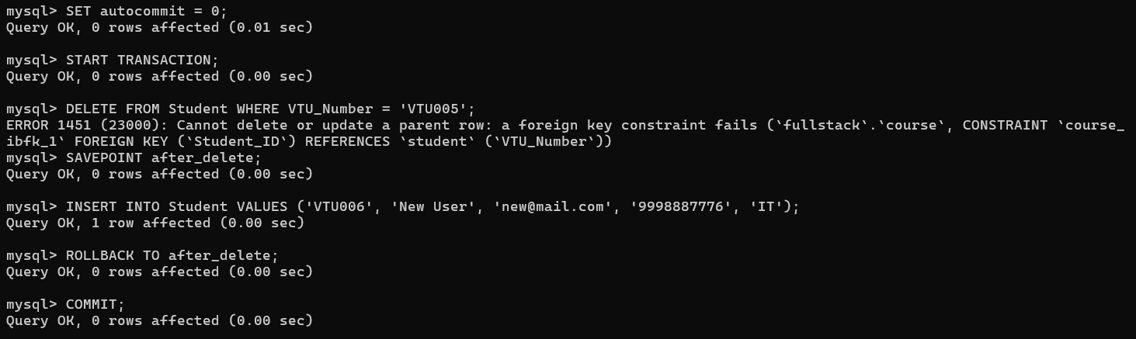

Step 2: User-Defined Function (Mathematical)
This function can be used to calculate a simple score or value for a project.
DELIMITER //
CREATE FUNCTION CalculateProjectScore(val1 INT, val2 INT)
RETURNS INT
DETERMINISTIC
BEGIN
RETURN val1 + val2;
END //
DELIMITER ;
SELECT CalculateProjectScore(10, 20) AS Total_Score;
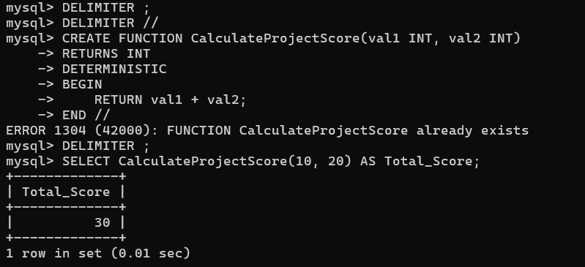
Step 3: User-Defined Function (Data Retrieval)
This function returns a specific value from a table based on an input.
DELIMITER //
CREATE FUNCTION GetStudentDept(vtu_id VARCHAR(20))
RETURNS VARCHAR(50)
DETERMINISTIC
BEGIN
DECLARE dept_name VARCHAR(50);
SELECT Department INTO dept_name FROM Student WHERE VTU_Number = vtu_id;
RETURN dept_name;
END //
DELIMITER ;
SELECT GetStudentDept('VTU001') AS Department_Name;
